Measurements for: telephone:
Height: cm dress size:
E-Mail: @
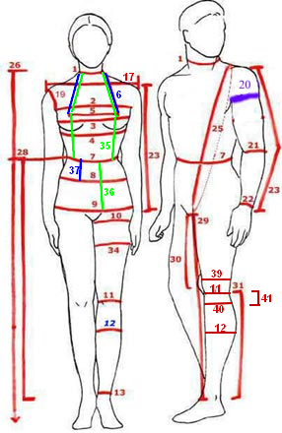
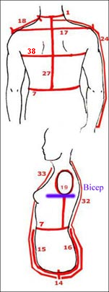
*Measure from one breast apex to the other, around the back of the neck. DIVIDE THE RESULT BY 2 | **Measure from bottom of waist elastic, up across bust apex, around back of neck, and down across breast apex to the bottom of waist elastic. DIVIDE THE RESULT BY 2.
  Torso (please stand relaxed and upright)
  1 | neck circumference | cm
  2 | upper breast circumference,  directly under the armpit | cm
  3 | Breast circumference over nipples | cm
  4 | Under the breast circumference | cm
  5 | Bust Span | cm
  6 * | Bust Height * | cm
  7 | Waist circumference | cm
  8 | Abdomen circumference | cm
  9 | Hip circumference | cm
  14 | Front Waist to back waist through crotch | cm
  15 | Rise (front) | cm
  16 | Rise (Back) | cm
  17 | Across Shoulder from back | cm
  25 | Around shoulder neck (through crotch) | cm
  26 | Back neck to floor | cm
  27 | Back length /Back neck to Waist | cm
  28 | Waist to Anckle | cm
  32 | Back neck to crotch | cm
  33 | Front neck to crotch | cm
  35** | Waist Height | cm
  36 | Hip Height | cm
  37 | Abdomen Height | cm
  38 | Back width | cm
  Arms (the arm should be hanging relaxed)
  18 | Shoulder lentgh | cm
  19 | Armole (around) | cm
  20 | Bicep (around) | cm
  21 | Elbow (around) | cm
  22 | Wrist (around) | cm
  23 | Arm Length (shoulder to wrist) | cm
  24 | Center back (neck-to-wrist) | cm

  Legs
  10 | Upper Thigh (around) | cm
  11 | Knee (around) | cm
  12 | Calf (around) | cm
  13 | Anckle (around) | cm
  29 | Inseam | cm
  30 | Crotch to knee | cm
  31 | knee-to- anckle | cm
  34 | Mid Thigh (around) | cm
  39 | Over the knee | cm
  40 | Under the knee | cm
  41 | Knee to calf (thickest point) | cm
How to measure :
Neck Circumference: Measure around lowest part of neck, at the base
Bust Circumference: Marked with elastic. Measure around the fullest part of the bust, keeping the tape high at the back

Waist Circumference: Measure waist at the elastic tape

Abdomen Circumference: Measured on the level where abdomen circumference is maximum.

Hip Circumference: Measured over the largest part of your bottom/thighs (at elastic)

Bust Span: Horizontal distance between bust apexes (also called bust bridge).
Measured along bust elastic.

Bust Height: Measure from center of back neck over shoulder to apex of one breast. To be sure to get right measurements, take this and bust height as a link around neck (=double) and divide the result by 2 .

Waist Height: Measure from center of back neck over shoulder to breast apex
and from there vertically to lower edge of waist elastic. To be sure to get right measurements, take this and bust height as a link around neck (=double) and divide the result by 2

Back length: Measure from center of back neck to lower edge of waist elastic

Back width: hang your arms relaxed on your sides. The measurement is taken horizontally between shoulder blades (i.e. from sleeve seam to sleeve seam), from and to the point where your arm meets your body (but not to armpit) about 4" (10cms) from neck downwards.

Shoulder length: Measure from neck to shoulder tip. Shoulder tip is found when you raise your arm to horizontal position and feel where there is hollow/pit between shoulder and arm bones. Hold your arm horizontal, if necessary, to find this point.

Waist-Abdomen: Measure vertically from lower edge of waist elastic to lower edge of abdomen elastic. Measure at front center.

Waist-Hip: Measure vertically from lower edge of waist elastic to lower edge of hip elastic. Measure at the side.

Biceps circumference: Measure at widest point of upper arm.

Wrist circumference: Measure over wrist bone

Overarm: Arm length from shoulder tip (as described above) to wrist. Bend arm slightly and measure over outside of elbow.

Outside seam: Measure from waist over the outside curvature of the hip to the esired cuff length.

